**FINAL PROJECT REPORT**

**PROJECT : SUBROTO**

**ROBOTICS**

**INTERNET OF THINGS / 2024-2**

**BATCH 2023**



**Bagus Eka Bagaskara  
Muhammad Imam Alghifary  
Reno Bakti  
Richly Harald Januar**

**February 2025**

**1. INTRODUCTION**

Autonomous Mobile Robots (AMRs) are increasingly used in various industries for automation, logistics, and assistance in hazardous environments. This project involves the development of a basic AMR equipped with a robotic arm, which plays a crucial role in navigation. The problem addressed by this project is the need for a mobile robotic system called SUBROTO that can autonomously navigate and locate safe paths while also responding to fire hazards.

The primary goal of this project is to design and implement an AMR capable of autonomous navigation and fire response. The objectives include:

* Developing a mobile robot platform with autonomous navigation.
* Utilizing a robotic arm equipped with an HC-SR04 ultrasonic sensor to assist in pathfinding.
* Implementing a control system for coordinated movement.
* Testing the system in a controlled environment to evaluate its performance

**2. MATERIALS AND METHODS**

**2.1 Materials Used**

This project involves both hardware and software components:

**Hardware:**

* **Motors:** L289N Motor Driver, 4 DC Motors, 4 Micro Servo
* **Sensors:** HC-SR04 (distance), KY-026 (flame sensor), DHT11 (temperature sensor)
* **Microcontroller/Processor:** Arduino Uno
* **Robotic Arm:** 4-DOF robotic arm
* **Power Supply:** Rechargeable lithium battery.

**Software:**

* **Robot Operating System (ROS):** Arduino IDE
* **C++:** Programming languages for control algorithms.

**2.2 Workflow**

The development process follows these steps:

1. **Hardware Assembly:** Setting up the mobile base and robotic arm, and connecting them to the microcontroller.
2. **Software Development:**
   * Programming movement and navigation algorithms.
   * Integrating sensors for real-time data collection.
   * Implementation of the robotic arm as a scanning mechanism for improved navigation
3. **Implementation:**
   * Testing each component (motors, sensors, arm) separately.
   * Combining all systems for autonomous operation.
4. **Troubleshooting:**
   * Debugging sensor readings and motor responses.
   * Ensuring stable communication between all components.
5. **Testing & Evaluation:**
   * Running real-world tests to measure navigation and object manipulation accuracy.

**2.3 Flowchart**

This flowchart represents the decision-making process for SUBROTO that detects flames and navigates its environment accordingly. Below is a step-by-step explanation of how the system operates:

1. **Start:**The process begins when the system is activated.
2. 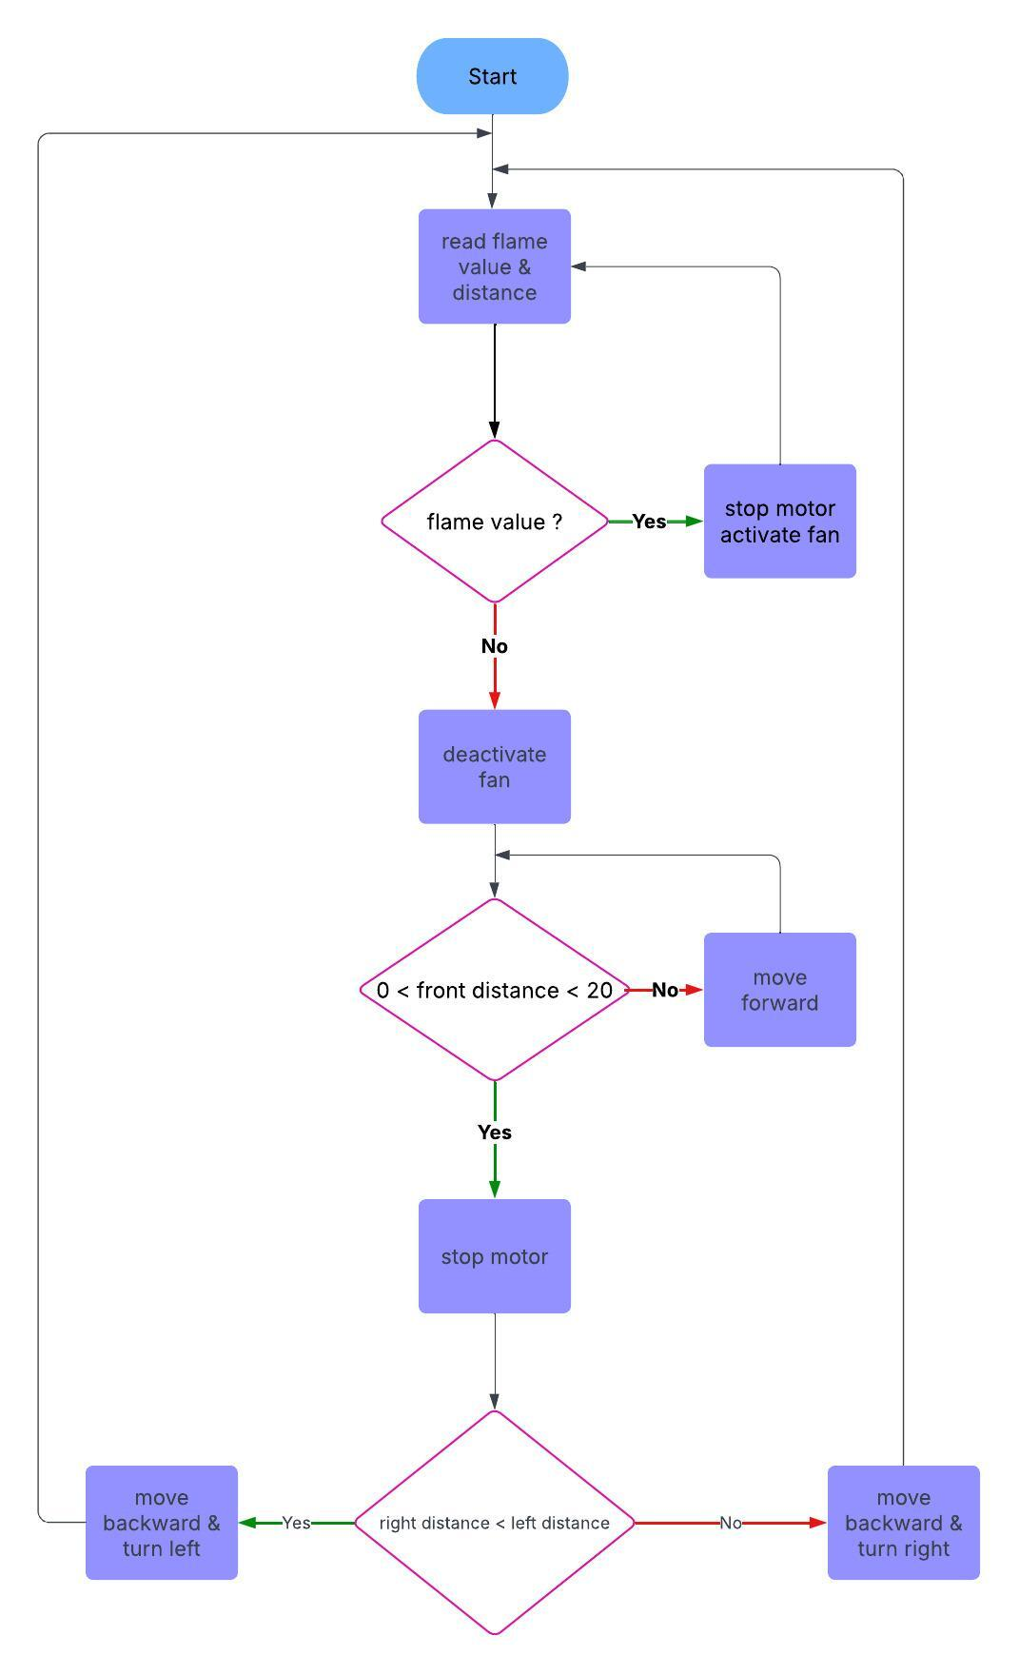**Read Flame Value & Distance:**SUBROTO reads sensor values to detect flame presence and measure distances to obstacles.
3. **Flame Detection Decision:**
   * If a flame is detected, the robot stops the motor and activates the fan to extinguish the fire.
   * If no flame is detected, the fan is deactivated, and the robot proceeds to move forward.
4. **Obstacle Detection (Front Distance Check):**
   * If there is no obstacle in the range of 0 < front distance < 20, the robot moves forward.
   * If there is an obstacle within this range, the robot stops the motor to prevent a collision.
5. **Directional Decision:**
   * The robot compares the right and left distances.
   * If the right distance is less than the left distance, the robot moves backward and turns left to avoid the obstacle.
   * Otherwise, the robot moves backward and turns right to find a clearer path.
6. **Loop Back:**After taking action based on the directional decision, the system loops back to continue monitoring the environment, ensuring continuous operation.

**3. RESULTS AND DISCUSSION**

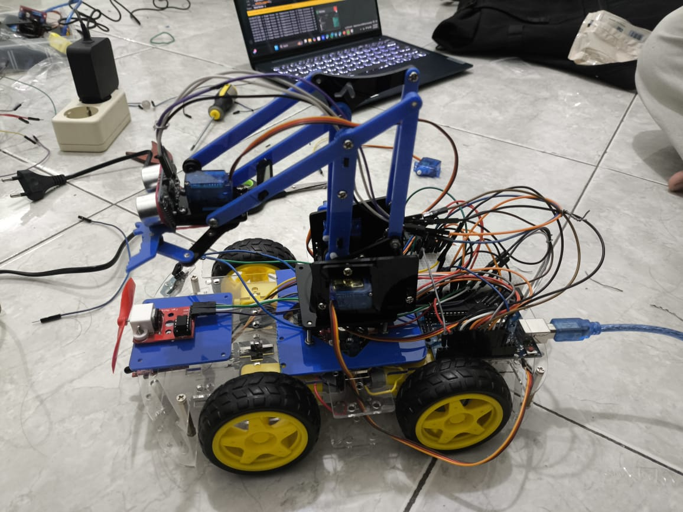

Figure . Picture of SUBROTO

SUBROTO is designed for autonomous navigation and fire detection, featuring a 4-DOF robotic arm, a wheeled base, and multiple sensors for obstacle avoidance.

**a. Key Components & Functions**

* **Mobile Platform**: Four-wheeled chassis powered by DC motors for movement.
* **Robotic Arm (Navigation Support)**: Mounted with an HC-SR04 ultrasonic sensor, it scans the environment to assist navigation.
* **Sensors:**
  + **HC-SR04 (on arm)**: Detects obstacles and helps pathfinding.
  + **Flame Sensor**: Intended for fire detection, but currently unreliable and requires improvement.
* **Fire Extinguishing Mechanism**: A fan is activated if fire is detected, but further testing is needed.
* **Control System**: Arduino & Raspberry Pi manage motor control and decision-making**.**

**b. How It Works**

1. The AMR starts scanning its surroundings using the robotic arm’s ultrasonic sensor.
2. It moves forward autonomously, avoiding obstacles based on sensor data.
3. If fire is detected, it stops and activates the fan to extinguish small flames.
4. If an obstacle is too close, the robotic arm searches for a better path, and the AMR adjusts its direction.

**c. Current Limitations**

* Navigation may struggle in complex environments and needs optimization

**4. CONCLUSIONS**

The developed AMR successfully demonstrated autonomous navigation and fire response capabilities. The system integrates multiple sensors, control algorithms, and a robotic arm that assists in navigation rather than object manipulation. By utilizing an HC-SR04 sensor, the robotic arm scans its surroundings, helping the AMR identify obstacles and determine safe paths. This enhances the robot’s ability to move efficiently in complex environments.

**Limitations & Future Work:**

* **Limitations:**
  + The battery life needs improvement for longer operation.
  + Navigation can be affected by dynamic environments.
* **Future Work:**
  + Improving battery efficiency for extended use.
  + Implementing AI-based decision-making for greater adaptability.